Hollis Veal

Update Use Cases:

A Simple Manager HomeScreen where the Manager can decide what to do:

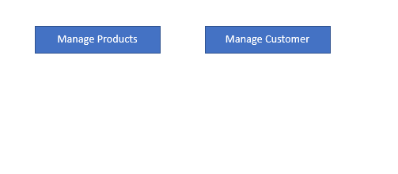

Example Update Product Screen:

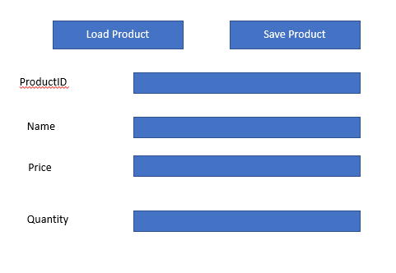

Example Update Customer Screen:

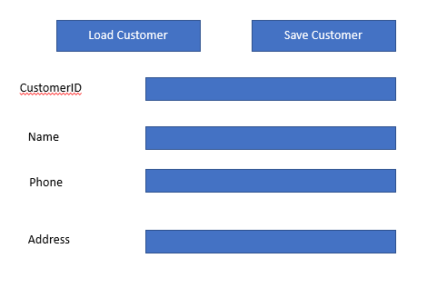

Example of an Update Purchase Screen:

